**Project Report: Checkers Game**

**Group Members:**

Syed Yousha: k226007 - Leader

Muhammad Yasir: k225090

Filza Salman: k225011

**Introduction**

The Checkers Game project is an implementation of the classic checkers board game. Developed as a console application in C++, the project focuses on providing an interactive and engaging experience for two players. The game involves strategic moves, captures, and promotes regular pieces to kings as they traverse the board.

**Real-World Application of the Project**

Checkers is a well-known and widely played board game. The digital implementation offers a platform for players to enjoy the game remotely, practice their strategic thinking, and compete against each other. This project serves as an accessible and entertaining way for users to experience the traditional checkers game on a computer.

**Displaying the Game Board**

The game board is displayed in the console, showcasing the positions of the pieces and providing a visual representation of the ongoing game.

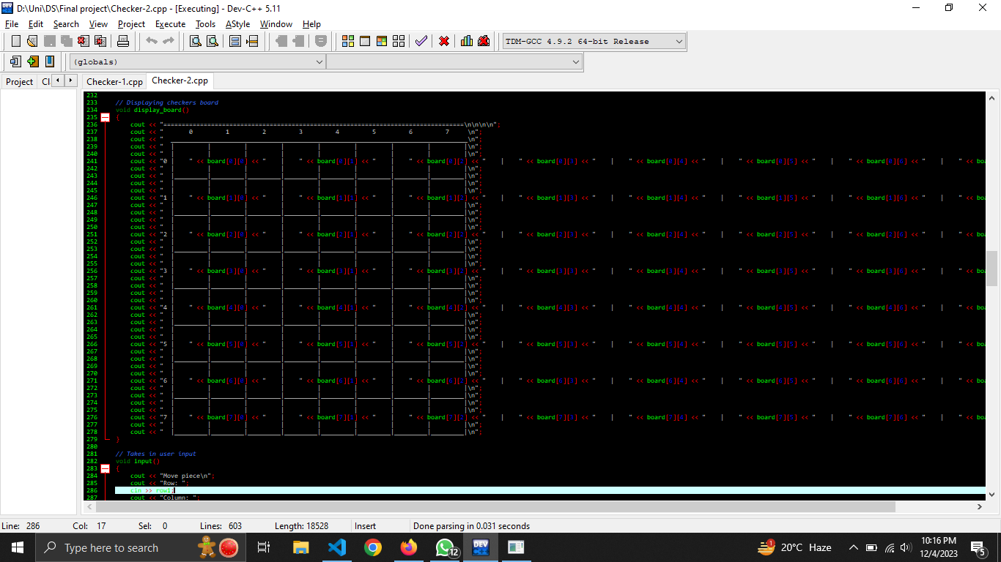

**Player Interaction**

Players interact with the game by inputting their moves. The console prompts players to enter the coordinates of the piece they want to move and the destination coordinates.

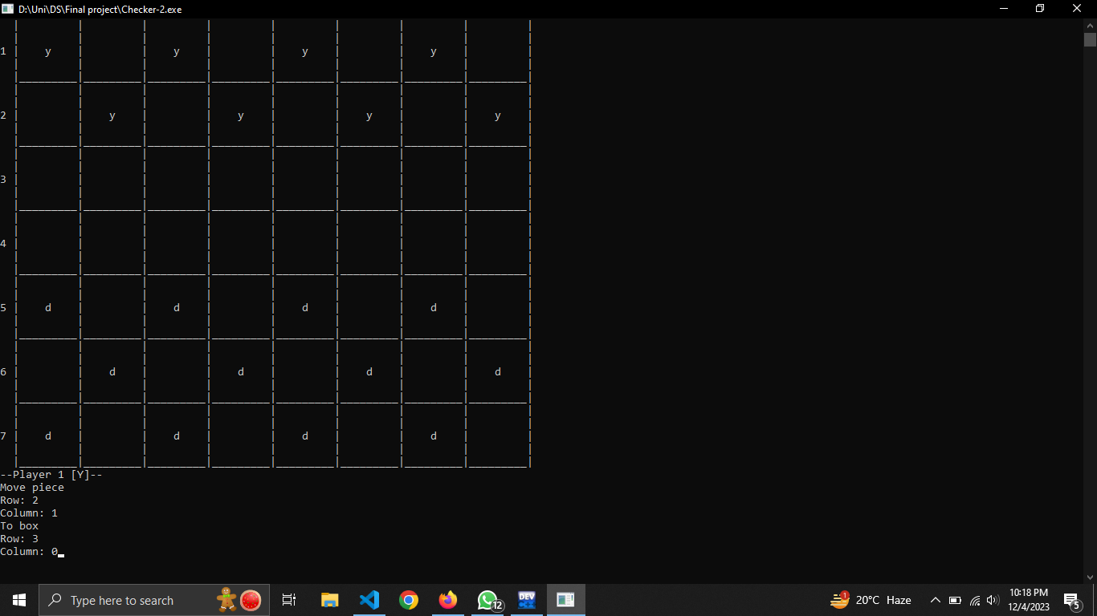

**Captures and Leaps**

The game supports captures and leaps, allowing players to strategically eliminate opponent pieces by leaping over them. The screenshots below depict a leap over an opponent's piece.

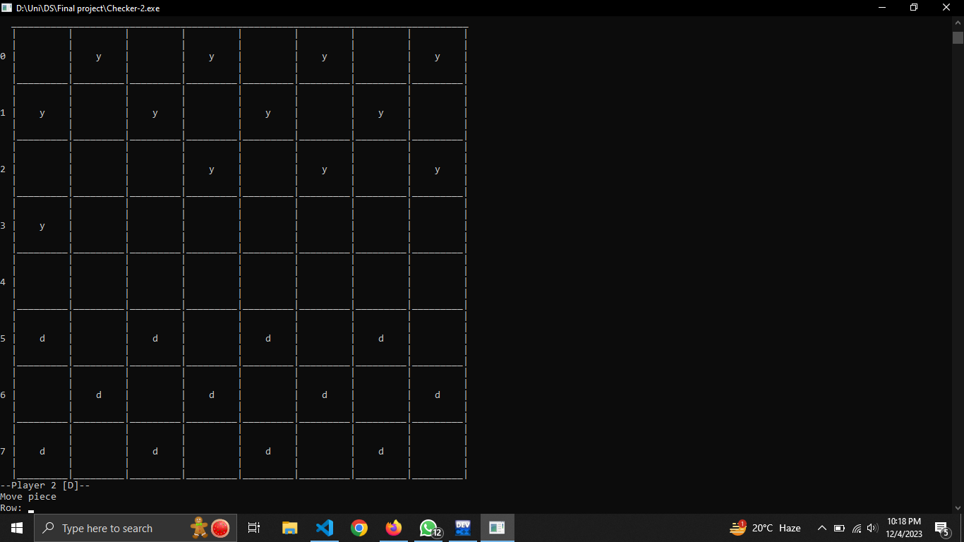

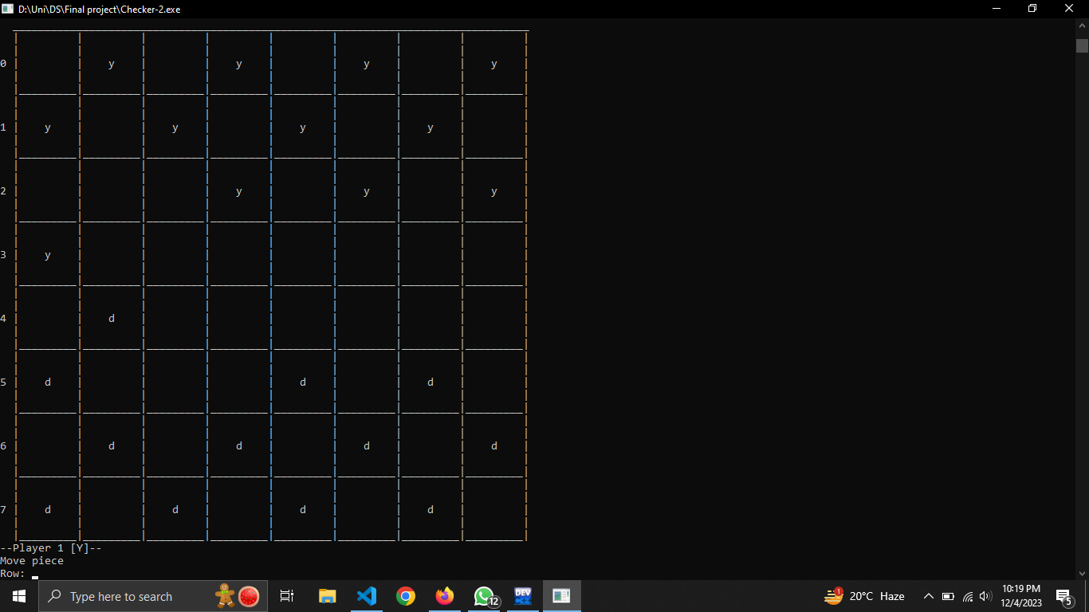

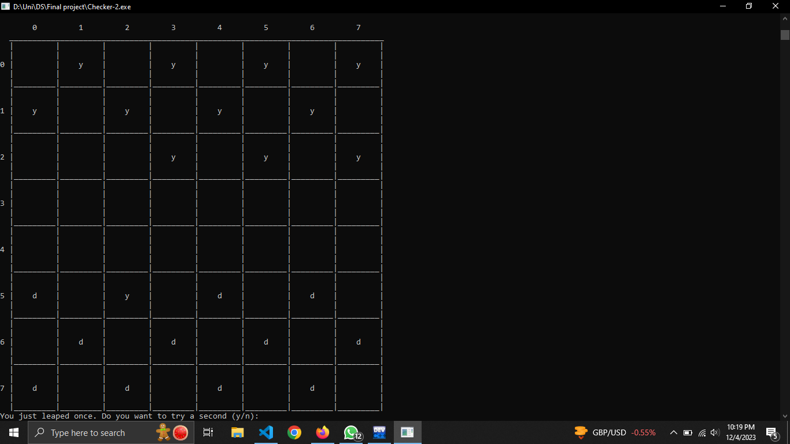

**End of Game**

The game concludes when one of the players achieves victory by eliminating all the opponent's pieces. A message is displayed, indicating the winner.

**Challenges Faced During the Project**

**Implementation of Leap Mechanism**

One major challenge was implementing the leap mechanism correctly. Ensuring that the game correctly detected and executed leaps over opponent pieces required careful consideration of various scenarios.

**User Input Validation**

Validating user input to prevent illegal moves and ensuring a smooth user experience posed a challenge. Handling incorrect inputs and prompting users for correct input improved the overall usability of the application.

**Game Logic Optimization**

Optimizing the game logic to efficiently handle moves, captures, and checks for victory without compromising the game's performance was an ongoing process. Refactoring and testing were essential to achieving a balance between functionality and performance.

In conclusion, the Checkers Game project presented valuable insights into game development, algorithm optimization, and user interaction. Overcoming challenges enhanced problem-solving skills and contributed to a robust and enjoyable gaming experience.

**Enjoy the game.**